LAB 7: Configuration of Switch, VLAN configuration and Inter-VLAN Routing

OBJECTIVES :
- To create and configure multiple VLANs on a network switch.
- To configure trunking and assign switch ports to appropriate VLANs.
- To implement and verify Inter-VLAN Routing using a router.

THEORY :
- Switch Configuration:
A switch is a Layer 2 networking device that connects multiple devices within a Local Area Network (LAN). It forwards data frames based on MAC addresses, ensuring efficient, collision-free communication. Proper switch configuration includes enabling interfaces, assigning ports to VLANs, and managing traffic flow, which enhances network performance and organization.

- Virtual Local Area Network(VLAN):
A VLAN (Virtual Local Area Network) is a logical subdivision of a network within a switch. VLANs group devices based on function or department rather than physical location, reducing broadcast traffic, improving security, and simplifying network management. Each VLAN acts as an independent broadcast domain.

- VLAN Configuration:
Configuring VLANs involves creating VLANs with unique IDs and names, then assigning switch ports to specific VLANs in access mode. Devices within the same VLAN can communicate directly, while communication between different VLANs requires a Layer 3 device such as a router.

- Inter-VLAN Routing:
Inter-VLAN routing enables communication between different VLANs through a Layer 3 device. In this experiment, the Router-on-a-Stick method is used, where a single router interface is divided into multiple sub-interfaces. Each sub-interface is configured for a specific VLAN using IEEE 802.1Q encapsulation.

NETWORK TOPOLOGY:
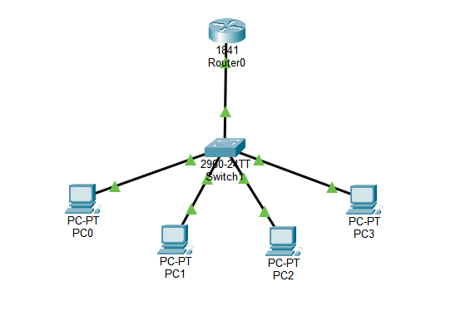
OBSERVATION:
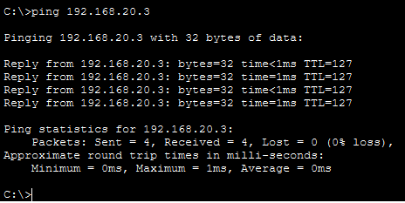
Fig: Ping in Different LAN

CONFIGURATIONS:
VLAN and IP Addressing Scheme:
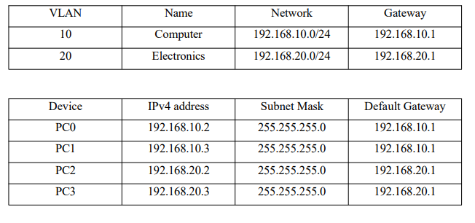
COMMANDS:
Switch Configuration :
Step 1: Create VLANs
Switch(config)# vlan 10
Switch(config-vlan)# name Computer
Switch(config-vlan)# exit
Switch(config)# vlan 20
Switch(config-vlan)# name Electronics
Switch(config-vlan)# exit

Step 2: Assign Ports to VLANs
# Assign Fa0/1 and Fa0/2 to VLAN 10 (Computer)
Switch(config)# interface range fa0/1-2
Switch(config-if-range)# switchport mode access
Switch(config-if-range)# switchport access vlan 10
Switch(config-if-range)# exit
# Assign Fa0/3 and Fa0/4 to VLAN 20 (Electronics)
Switch(config)# interface range fa0/3-4
Switch(config-if-range)# switchport mode access
Switch(config-if-range)# switchport access vlan 20
Switch(config-if-range)# exit

Step 3: Configure Trunk Port (Switch ↔ Router)
Switch(config)# interface fa0/5
Switch(config-if)# switchport mode trunk
Switch(config-if)# exit

Step 4: Verify VLAN Configuration
Switch# show vlan brief
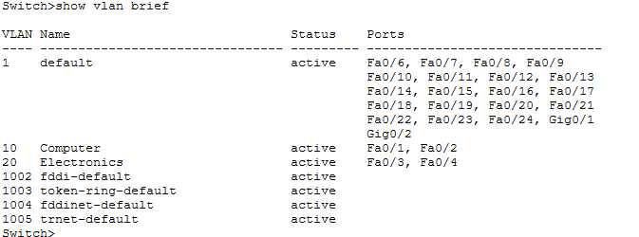

Step 5: Router Configuration (Inter-VLAN Routing)
# Configure sub-interface for VLAN 10
Router(config)# interface GigabitEthernet0/0.10
Router(config-subif)# encapsulation dot1Q 10
Router(config-subif)# ip address 192.168.10.1 255.255.255.0
Router(config-subif)# exit
# Configure sub-interface for VLAN 20
Router(config)# interface GigabitEthernet0/0.20
Router(config-subif)# encapsulation dot1Q 20
Router(config-subif)# ip address 192.168.20.1 255.255.255.0
Router(config-subif)# exit

RESULT:
The switch was set up with multiple VLANs, and all ports were assigned to their designated VLANs successfully. A trunk connection between the switch and router was configured, allowing VLAN data to flow seamlessly. Using router sub-interfaces for Inter-VLAN routing, devices were able to communicate within the same VLAN as well as across different VLANs without issues.
DISCUSSION:
By implementing VLANs, the network was divided into separate logical segments, reducing broadcast congestion and improving efficiency. Proper port assignments grouped devices according to their respective VLANs. The trunk link enabled multiple VLANs to share a single router interface, facilitating smooth communication. Inter-VLAN routing ensured that traffic between VLANs was controlled and secure, maintaining network segmentation. Verification commands confirmed that the configurations were applied correctly and were functioning as intended.

CONCLUSION:
This experiment successfully demonstrated the creation of VLANs, trunk configuration, and Inter-VLAN routing using the Router-on-a-Stick approach. It highlighted how VLANs can optimize network performance, manage traffic effectively, and enable secure communication between different segments of a network, proving the importance of structured network design.

